Challenge Number 970
Played on date: November 16, 2016 Time: 2:00 pm
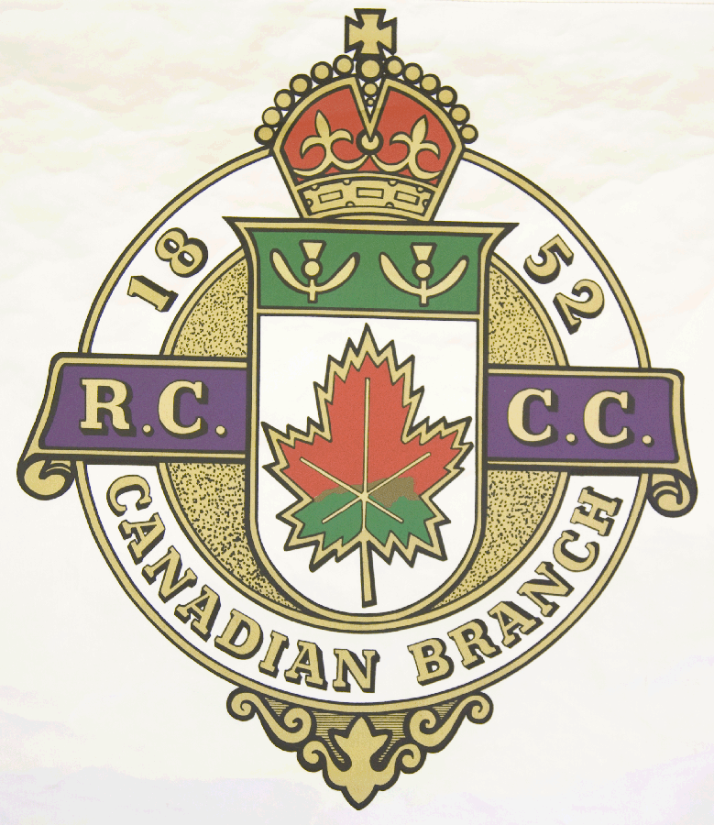
Hosting Club: Windsor (Lennoxville Curling Club).

Host Club Address: 6 Speid St. .

Host Club City: Sherbrooke, Qc.

Host Club Telephone: (819) 562 – 2310 .

Host Contact Person: Jim Mastine

Contact phone or email: mastine@sympatico.ca

Hosting Club: Windsor . Challenging Club: Brockville .

Skip: Marc Richard . Skip: Harold Mooibroek ..

Third: Jim Mastine . Third: Mark Peacock

Second: Daniel Mercier .. Second: Fraser Coggan

Lead: Robert Léveillé .. Lead: Bob Jordan

Skip: Benoît Bernier .. Skip: Matt Hone

Third: Marc-André Massé.. Third: Kevin Cook

Second: Pierre Massé .. Second: Jon O’Rielly

Lead: Richard Frappier .. Lead: Stuart Fergusson .

 | Skip | 1 | 2 | 3 | 4 | 5 | 6 | 7 | 8 | 9 | 10 | Score
Sheet  1 | H. Mooibroek | 1 | 0 | 1 | 0 | 1 | 0 | 2 | 0 | 0 | 0 | 5
Sheet  1 | M. Richard | 0 | 2 | 0 | 2 | 0 | 1 | 0 | 1 | 1 | 1 | 8
Sheet  2 | M. Hone | 1 | 0 | 4 | 0 | 1 | 1 | 0 | 2 | 0 | 0 | 9
Sheet  2 | B. Bernier | 0 | 0 | 0 | 1 | 0 | 0 | 0 | 0 | 2 | 1 | 4

Hosting club Score: 12 . Challenging club score: 14 .

Note: Description of the game should follow on separate page as well as photos of the teams.

